* Database Management system -It is a software through which we execute SQL queries.
* There are many databases like-Oracle, Microsoft sql server,MY SQL Lite and many other things.
* Server is a database in where different storage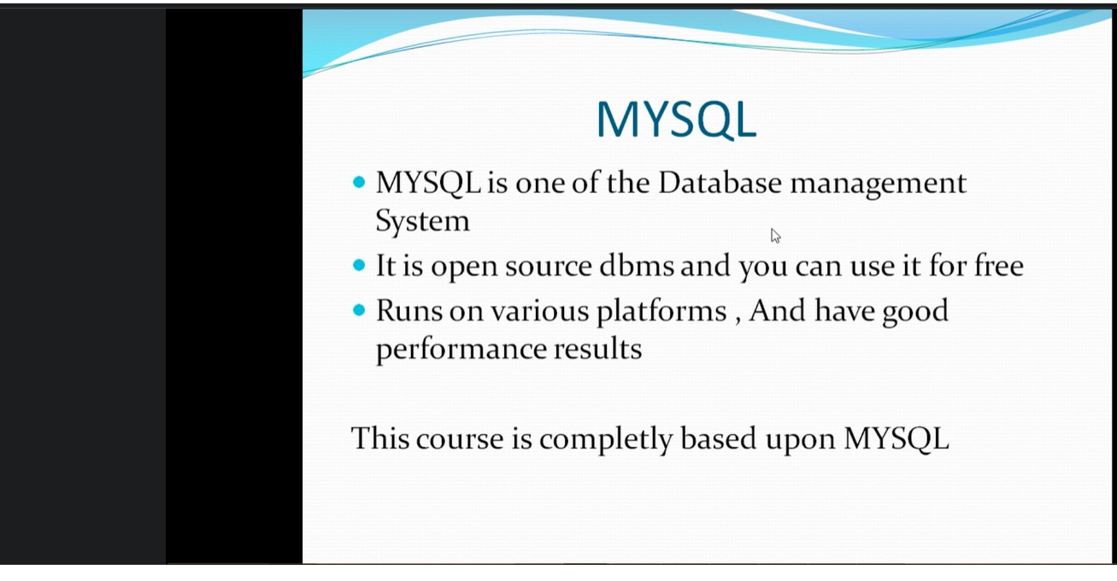e is there with sql we can extract the data from database.
* While executing the command you have to select the command which you want to run otherwise sql will run all the commands.
* If there are 5 databases and you are selecting use command then control will go to that database.
* create table Employeeinfo(name varchar(20),id int ,location varchar(20), age int);
* If you want to check the description then describe Employee info;
* If you want to insert values in database then simply use:-
* insert into Employeeinfo values('sam',1,'newjersy',21);
* describe Employeeinfo;
* Select name,id from Employeeinfo;
* Select* from Employeeinfo;
* If you want to add any new column in employee info table
* Alter Table Employeeinfo add gender varchar(10);
* Alter command is basically used to adding the column name modifying the column name and deleting the column name, it is not about the data and values.If you want to change the values in table we can use update.
* Alter Table Employeeinfo modify gender varchar(10);
* Alter Table Employeeinfo drop gender varchar(10);
* Update values in Table-
* update EmployeeDetails set gender ='female' where name= 'Vijay';
* update tablename set col= ‘Value’ where col=data
* If you want to delete any row:-
* Delete from EmployeeDetails where name=’Lam’;
* Select is basically used to retrieve data from employeedetails3;
* If you want to extract any column value we use select command.
* #get the employee name where salary is equal to 50000
* Select name from employeedetails3 where Salary =50000;
* Select name,Salary from employeedetails3 where Salary >50000
* #get the employees name of Florida where there age should be less than 23 or location is from charlotee;
* Select name from EmployeeDetails3 where (city ='Chittorgarh' and Address= 'Sadar Bajar Akola') or Salary>60000;
* Select name,id from Employeeinfo where id=2 or id=4; Output of these query will be:-
* Name id
* Ram 2
* Ram 4
* #get the name ,id and location where id is either equal to 2 or location is equal to newjersy.
* Select name,id,location from Employeeinfo where id=2 or location='newjersy';
* #Print the employees where age should is equal to 21 and 35.

Select name,age from Employeeinfo where age in(21,35);

* #Print the employees where id should between 1,5
* Select name,id from Employeeinfo where id between 1 and 5;
* Select name from employeeinfo where age not between 21 and 31:-
* **Select name,age from Employeeinfo where age not between 21 and 31;**
* **Regular expression: - Two major expression % and _**
* **If you want to get any number whose first character is a then you have to write in this manner a%-Select name from city where countrycode like ‘A%’**
* **If you want to get any c as second character then this is the method you have to write-**
* **__c%**

**Use qadbt;**

* **If you want to sort any name in descending order then we can use order by;**
* **Select * from employeeinfo order by id desc;**

**15-02-2025-**

* **Group By functions: -**

**1.Get Total Sum of amount generated for each month**

**Select sum (Amount),month from Transactions299 group by Month;**

|  |  |  |  |
| --- | --- | --- | --- |
| Month | Day | Amount | branch |
| feb | 13 | 124 | bangalore |
| feb | 17 | 20400 | chicago |
| feb | 212 | 320 | sydney |
| mar | 22 | 9600 | bangalore |
| mar | 16 | 5200 | chicago |
| april | 12 | 23 | sydney |
| Jan | 13 | 666 | bangalore |
| may | 2 | 3111 | sydney |
| may | 1 | 99999 | paris |
| Jan | 12 | 2000 | paris |

**2.** **Get Maximum Transaction generated for each month**

**Select max(Amount),month from Transactions299 group by Month;**

**3. Get Minium Transaction generated for each month**

**Select min(Amount),Month,branch from Transactions299 group by branch;**

Importance of Having keyword-If you want to know count in the table :- Select count(*) from Transactions299;

**Get Average Amount generated for each month-**

**Select count(*), Month from Transactions299 group by Month;**

**4.** **Get the Transactions which occurred less than 2 for any month-**

**Select count(*), Month from Transactions299 group by Month having count(*)<2;**

5. **Get Total Sum of amount generated for each month only in Bangalore  
or Chicago branches**

**Select count(*), Month from Transactions299 group by Month having count(*)<2;**

* Having will always come after group by functions

**Where is applied on table and having is applied on group results.**

**Select sum(Amount),month from Transactions299 where branch=’** bangalore’ or **branch =’** chicago’

**group by Month ;**

**7.** Get the month which has total sale amount less than 1000 when I combine both sydney and paris branches

**Select SUM(Amount) AS TotalAmount, Month**

**FROM Transactions299**

**WHERE branch = 'bangalore' OR branch = 'sydeney'**

**group by Month having TotalAmount<10000**

**8.** Which branch have more than total sum of 4000Bucks in Feb

**SELECT SUM(Amount),branch from Transactions299 where Month= 'feb' group by branch having SUM(Amount)>4000;**

Reference for basic queries

use Trust2;

describe employeedetails3;

Select* from employeedetails3;

Select Salary,Address from employeedetails3;

#Unique Names in Employees table

Select distinct name from employeedetails3;

#get the employee name where salary is equal to 50000

Select name from employeedetails3 where Salary =50000;

Select name,Salary from employeedetails3 where Salary >50000;

Alter table employeedetails3 add city varchar(20);

Insert into EmployeeDetails3 values("Raghav",5,10000,"Sadar Bajar Akola","Udaipur");

Insert into EmployeeDetails3 values("Shubham1",6,20000,"Sadar Bajar Akola1","Chittorgarh");

Insert into EmployeeDetails3 values("Shubham2",7,30000,"Sadar Bajar Akola2","Kapasan");

Insert into EmployeeDetails3 values("Vijay3",7,40000,"Sadar Bajar Akola2","Nathwara");

Insert into EmployeeDetails3 values("Keshav4",8,50000,"Sadar Bajar Akola2","Sangod");

Insert into EmployeeDetails3 values("Keshav4",8,50000,"Sadar Bajar Akola2","Chittorgarh");

Select name ,salary from EmployeeDetails3 where Address='Sadar Bajar Akola' and Salary>10000;

Select* from EmployeeDetails3;

Select name from EmployeeDetails3 where (city ='Chittorgarh' and Address= 'Sadar Bajar Akola') or Salary>60000;

Select* from EmployeeDetails3 order by name;

Select * from EmployeeDetails3 order by Eid desc;